**Project Design Phase-II**

**Data Flow Diagram & User Stories**

| Date | 25 JUNE 2025 |
| --- | --- |
| Team ID | LTVIP2025TMID31965 |
| Project Name | Citizen AI – Intelligent Citizen Engagement Platform |
| Maximum Marks | 4 Marks |

**Data Flow Diagrams:**

A Data Flow Diagram (DFD) is a traditional visual representation of the information flows within a system. A neat and clear DFD can depict the right amount of the system requirement graphically. It shows how data enters and leaves the system, what changes the information, and where data is stored.

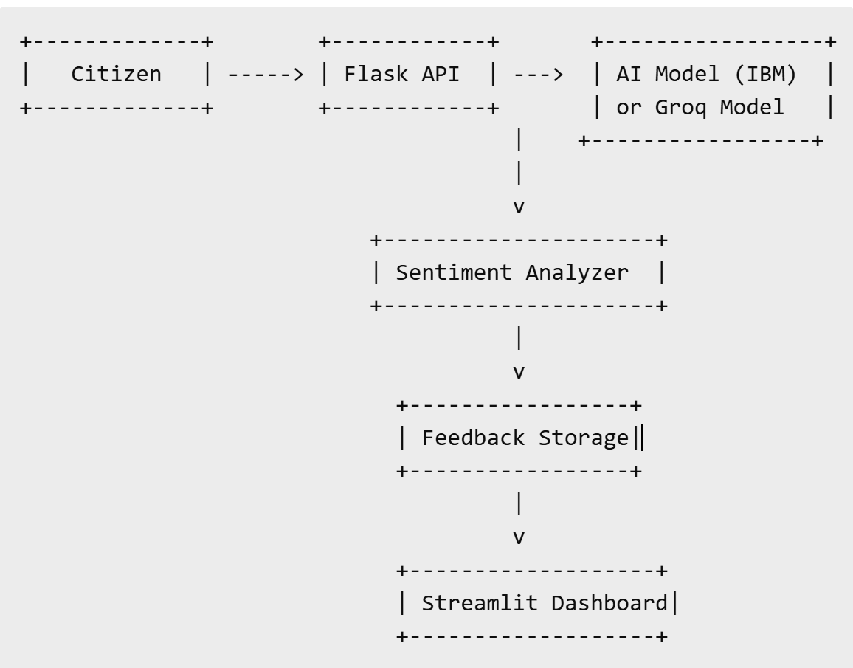

**User Stories**

Use the below template to list all the user stories for the product.

| **User Type** | **Functional Requirement (Epic)** | **User Story Number** | **User Story / Task** | **Acceptance Criteria** | **Priority** | **Release** |
| --- | --- | --- | --- | --- | --- | --- |
| Citizen (Web user) | Real-Time Chat Assistant | USN-01 | As a user, I can ask questions and receive AI-generated responses | System returns relevant responses instantly | High | Sprint-1 |
| Government Officer | Sentiment Dashboard | USN-02 | As a user, I can view sentiment analytics on citizen queries | Dashboard displays sentiment stats and trends | High | Sprint-2 |
| Admin (Web user) | System Configuration | USN-03 | As a user, I can change model tone and response detail level | Changes apply in real-time without crash | Medium | Sprint-2 |
| Developer (Internal) | Model Fallback Mechanism | USN-04 | As a user, I can switch between IBM and Groq models | Requests are routed correctly to fallback model | Medium | Sprint-3 |
| Analyst (Internal) | Feedback Export | USN-05 | As a user, I can export user feedback for external analysis | System exports clean CSV with accurate records | Low | Sprint-3 |